Calling All Junior Handlers!!
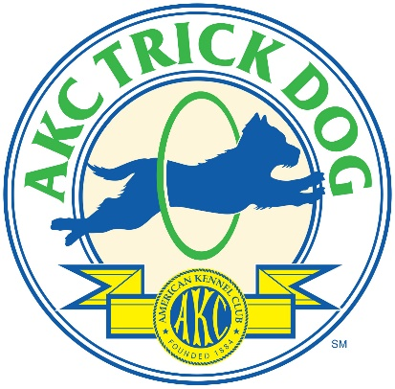
Looking for something fun to do at home?
AKC Trick Dog Titles are now being earned virtually!
It is fun and easy to participate!
There are five AKC Trick Titles you and your dog can earn:
- AKC Novice Trick Dog (TKN)- Your dog performs 10 skills from the Novice list. If a dog has a Canine Good Citizen (CGC) certificate or title on record at AKC, it can do 5 Novice tricks (CGC + 5) to earn the Novice title. See the list of tricks here.
- AKC Intermediate Trick Dog (TKI) – Your dog must have the Novice title, plus perform 10 Intermediate tricks. See the list of tricks here.
- AKC Advanced Trick Dog (TKA) – Your dog must have the Intermediate title, plus perform 10 tricks from the Advanced list. See the list of tricks here.
- AKC Trick Dog Performer (TKP) – In this title, handlers perform a short routine with at least 10 tricks with at least 3 tricks using props. See the requirements here.
- AKC Trick Dog Elite Performer (TKE) – In the highest level of Trick Dog, the Elite Performers perform a routine that has a story/script. At least 5 props are used. See the requirements here.
Just follow these steps!
- Video your dog performing the tricks necessary for the title you are applying for. (Note, the titles are successive, meaning you must earn the earlier title before applying for the next title)

- Email your video and the trick dog application with your junior handler number to Juniors@akc.org, our staff CGC evaluator will review your video, and email you your Evaluator Video Verification Form, we will also turn in your application for processing…soon you will get your new title certificate in the mail!

- If you have participated in a virtual trick dog evaluation already, the trick dog title application and the Evaluator Video Verification Form can still be emailed to juniors@akc.org.

- If your dog already has a trick dog title, the same procedure can be followed to apply for the advanced titles!

- All trick dog title applications submitted by a junior handler that are emailed to juniors@akc.org by August 1st, 2020 will be processed at no charge.

- 4-H members are invited to participate. Follow the steps above, if you need your junior handler number and/or a number for your dog to process the title, please email juniors@akc.org. We will email you the 4-H Special Form. Print it, fill it out and include it with your trick dog title application.

The AKC Junior department looks forward to seeing your videos!

